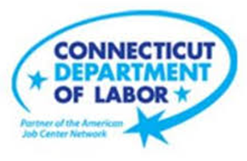

**NEW WEEKLY JOB POSTINGS FROM   
HELP WANTED ONLINE  
Office of Research**

**Week Ending July 9th, 2022: New Ads up 16% Over The Week to Over Ten Thousand**WETHERSFIELD, July 15th, 2022 – During the week ending July 9nd, there were 10,731 new postings, up 1,459 new ads or +16% over the week. Five industries had over a thousand new ads or more, ranging between Finance & Insurance (1,001 new ads) and Health Care & Social Assistance (1,897 new ads). These five industries with over a thousand new ads accounted for 6,927 or 65% of the total new ad count for the week. Employers with large over the week increases include Deloitte, Walmart/Sam’s, and McDonald’s. Occupations with the largest over the week increases Supervisors of Retail Sales Workers (+381 new ads), Food Service Managers (+172 new ads), and Real Estate Sales Agents (+134 new ads).  
  
  
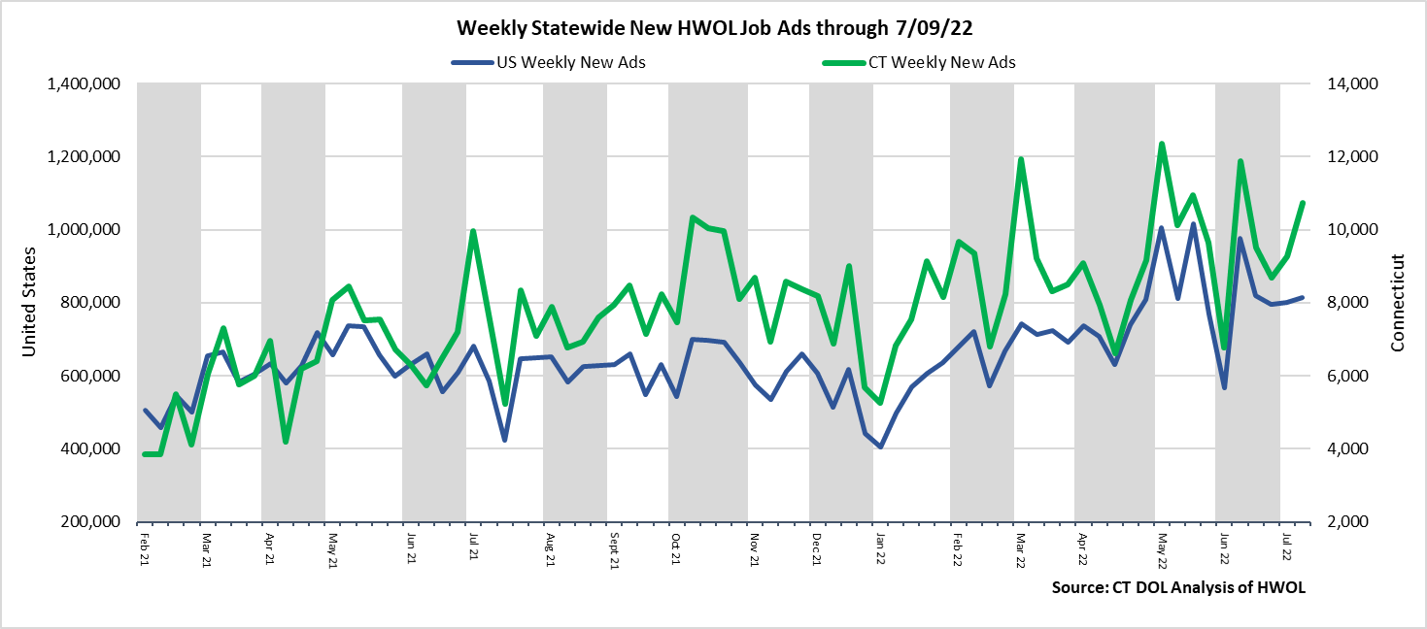  
**Industries** with the most new postings include Health Care & Social Assistance, Retail Trade, and Accommodation & Food Service.

**Occupations** with the most new postings include Supervisors of Retail Sales Workers, Registered Nurses, & Retail Salespersons.

**Employers** with the most new postings include Deloitte, Capital One, and Walmart/Sam’s.

**The three industries with the most new job postings were:**

* **Health Care & Social Assistance** (1,897 new postings, +11% over the week)
* **Retail Trade** (1,286 new postings, +25% over the week)
* **Accommodation & Food Service** (1,067 new postings, +114% over the week)

  
 During the week ending July 9th, 2022, the total ad increase of 1,459 new ads or +16% is the net result of increases in 12 of 21 industries. These 12 industries were up a combined 1,684 new ads, with the largest gains occurred in Accommodation & Food Services (+569 new ads), Pro., Sci., & Tech Services (+371 new ads), and Retail Trade (+261 new ads). The 9 declining industries fell by a combined 225 new ads and 8 of those 9 fell by 41 new ads or less. Over four weeks, ads were down by 1,193 new ads. The largest industry declines include Manufacturing (-385 new ads), Health Care & Social Assistance (-321 new ads), and Finance & Insurance (-310 new ads).   
  
 For more information on total job ads by industry for Connecticut and its labor market areas, see the monthly report available here: <https://www1.ctdol.state.ct.us/lmi/hwol.asp>

**New Job Postings by Occupation** 

**The occupations with the most new postings were:**

* Supervisors of Retail Sales Workers (617 new postings, +161% over the week)
* Registered Nurses (388 new postings, -13% over the week)
* Retail Salespersons (381 new postings, +5% over the week)

**Employers with the Most New Job Postings**

Employers with the most new job postings during the week were mostly in Finance & Insurance, Retail Trade, and Health Care. The 25 employers shown above account for 19 percent of all new ads. 20 of 25 employers in the top 25 had over the week increases. The largest increases in the top 25 include Deloitte (+286 new ads), Walmart / Sam’s (+128 new ads), and Yellow (+120 new ads). Over four weeks, 19 employers in the top 25 had increases, two were unchanged, and 4 had decreases. The largest four week increases include Deloitte (-241 new ads), Walmart / Sam’s (-129 new ads) and Yellow (-123 new ads).  
  
**What is HWOL?**The **Conference Board Help Wanted Online**® Data Series (HWOL) measures the number of new, first-time Online job postings and jobs reposted from the previous month for over 16,000 Internet job boards, corporate boards and smaller job sites that serve niche markets and smaller geographic areas. To view more HWOL data, go to: <https://www1.ctdol.state.ct.us/lmi/hwol.asp>